AUCTION DATE – 16th NOVEMBER 2017
To raise funds for Wesley including their work in the community especially for the young, older people, those with dementia and their careers. Commission bids are welcome before end of 15th November c/o Rupert Bertie, Wesley Methodist Church, Elm Road, Leigh-on-Sea, Essex or Rupert.bertie @coreassets.com
BIDDERS NAME AND CONTACT DETAILS:

PAINTED PET PORTRAIT
LOT 1 Donated by Marie Antoniou, 2017 David Shepherd Wildlife Artist of the Year finalist and highly commended. Voucher for 200x200mm painting. Reserve £75.00
BID
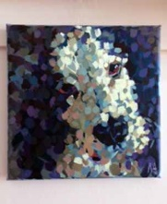

ONE HOUR FAMILY PORTRAIT SESSION AND A 6X8 FRAMED GIFT
LOT 2 Donated by Barret & Coe Photography. Reserve £80.00
BID

WEEKEND AFTERNOON TEA FOR TWO AT THE ROSLIN BEACH HOTEL
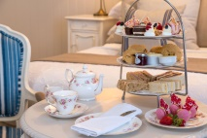
LOT 3 (Voucher can also be used towards lunch or dinner). Donated by Richard & Mary King. Reserve £25.00
BID

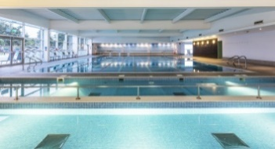
TWO WEEK FAMILY MEMBERSHIP AT DAVID LLOYD, SOUTHEND
LOT 4 Donated by David Lloyd Gym. Reserve £50.00
BID

TWO WEEKS HOLIDAY ACCOMMODATION IN ST KITTS
LOT 5 Picture - House and view
The accommodation is the upper part of the house and does not include the ground floor. The accommodation is of four bedrooms which can sleep up to ten people. It comprises a kitchen, utility, main bathroom, front room, cloakroom and two bedrooms each with an en suite.
Donated by Rupert and Janice Bertie, whose house it is. Reserve £400.00
BID
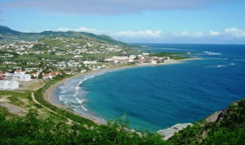
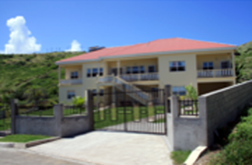

MEAL AT CUCINA RESTAURANT, BROADWAY WEST
LOT 6 (Gift Vouchers x 3. £20 x 2 and 1x£10) Donated by Scott & Stapleton, Estate Agents. Reserve £30.00
BID

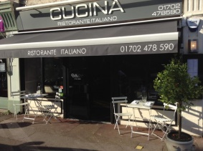

MEAL AT ROSE GARDEN RESTAURANT, LONDON ROAD, LEIGH-ON-SEA
LOT 7 (£40.00 gift voucher) Donated by The Rose Garden Restaurant. Reserve £30.00
BID
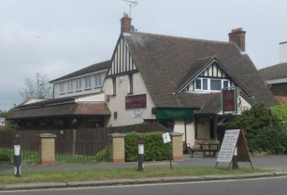

COLLECTION OF SOUVENIR TEASPOONS IN CABINETS
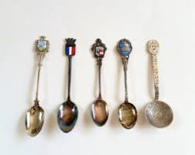
LOT 8 Library Picture - not actual spoons
Donated by Val & Brian Dickens, Hall Green Methodist Church, Birmingham. Reserve £20.00
BID

BID

GARDENING SESSION
LOT 9 Library picture
Donated by Gaye Greenway.
BID
ONE WEEK HOLIDAY IN NORFOLK
LOT 10 Week in a caravan donated by Rev Julia & Sam Monaghan. Reserve £120.00
BID
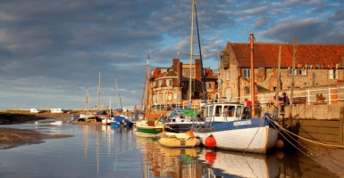

THREE HOURS HOUSE CLEANING
LOT 11 Donated by Pam, Becky & Sam Boughton-Smith.
BID

THE CORNER CLUB, BROADWAY, LEIGH-ON-SEA
LOT 12 Voucher worth £25
Donated by Joan and Geoffrey Hawkins.
BID

WESLEY THEATRE GROUP PANTOMINE TICKETS
LOT 13 Family Ticket (2 Adults, 2 Children) either Fri 1st Dec @ 7.30pm or Sat 2nd Dec @ 2pm or 6pm.
Donated by Wesley Theatre Group.
BID

HOME COOKED THREE COURSE MEAL FOR FOUR
LOT 14 Donated by Eileen Simmons and Geoff Nash.
BID
TWO PANTOMIME TICKETS – JACK AND THE BEANSTALK AT THE CLIFFS PAVILION
LOT 15 2 Tickets for rear stalls, Fri 22nd Dec at 7.15pm.
Donated by Southend Theatres.
BID

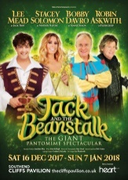

CHRISTMAS CAKE
LOT 16 Library picture
Donated by Janice and Rupert Bertie.
BID

SIX BOTTLES OF WINE
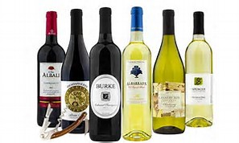
LOT 17 Library picture
Donated by Rupert and Janice Bertie & Richard and Mary King.
BID
BID

AFTERNOON TEA WITH CHAUFFEUR DRIVEN TRANSPORT AT THE RIVERSIDE GARDEN CENTRE
LOT 18 Joy will pick a max of 3 of you up from your home and take you to the Riverside Nursery Hullbridge. Once there you will have time to look around at plants and possible Christmas presents. Joy will pay for you to have lunch or afternoon tea in the café before she drives you home.
Donated by Joy Milner.
BID
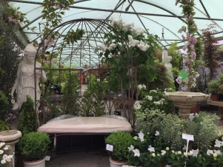

FISH AND CHIPS
LOT 19 A voucher for a fish and chip supper at the Perfect Plaice Fish and Chip Shop for four. The meal can be eaten in or taken away.
Donated by The Perfect Plaice.
BID

